Home > Electrical Isolation Transducer > Hall Effect Transducer > B23 Hall Effect Transducer
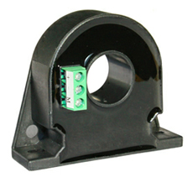
*Hall close-loop operational principle(electromagnetic balance principle), can measure current in any waveform, the output terminal can reflect the waveforms parameters of input current
*Response time is quick ≤1uS
*Controlled by temperature compensation circuit, measure accurately
*Perforation input, plug terminal, screw fastening plane mounting
*It widely applies to all kinds of industrial current online detection system
*Dimension(mm):68(L)×20(W)×60(H) aperture:20.5mm

*Standards:GB/13850-1998,IEC688:1992
*Input Range :0~400A can choose 0~50A, 0~300A etc
*Accuracy Grade :≤0.5%.F.S
*Linearity Degree:better than 0.2%
*Response Time:≤1US
*Frequency:0~100KHZ
*Offset Voltage:≤20mV
*Temperature Characteristics:≤150PPM/℃（0~50℃）
*Power Consumption :≤30mA+output current
*Isolation Withstanding Voltage: AC2.0KV/min*1mA between input/output/ power
*Load Capacity :2 times current continuous,30 times 1 second
*Flame Retardancy:UL94-V0
*Working Environment:-10℃~50℃,20%~90% without condensation
*Storage Environment:-40℃~70℃,20%~95% without condensation

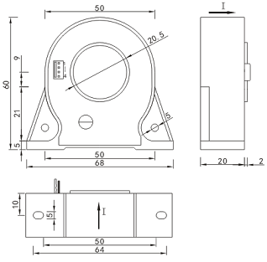

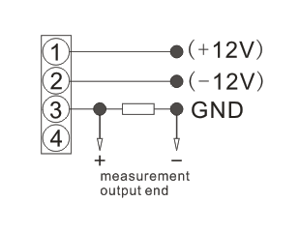


A---Output
2. Tracking current output (turnover rate1/1000)
2a. Tracking current output (turnover rate1/2000)
T: Special output
B---Power supply
5: ±12V±10%
6: ±15V±10%
C---Current input range
Model selection1: LF-DI12-25B23-1.0/0~200A
Explanation: this product is a 0~200A input range, 0~200mA tracking output,
±12V power supply, B23 style 1-way DC current transducer.

http://www.transducersensor.com/Electrical-Isolation-Transducer/Hall-Effect-Transducer/Hall-Effect-Transducer-DIB23.html

