
Gas Sensor NAP－55A

NAP－55A
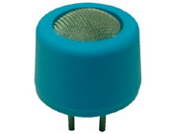
NAP-55A is a miniature & low power consumption type of NAP-2A, and is mainly used for gas detectors and leak testers. 55A is a half in height and needs a half in power consumption compared to 2A so that thinner and lighter-weight detectors can be produced. The following are the basic characteristics but it is recommended to refer to the individual user’s manual for further information. A measuring circuit for sensor evaluation is the same as NAP-2A.

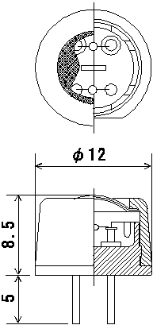
Target gases and concentration
Gases |  | Detection range
Methane | CH4 | 0.05－5％(0.05－2％)
Propane | C3H8 | 0.03－2.2％(0.03－1％)
Iso-butane | Iso-C4H10 | 0.03－1.8％(0.03－0.8％)
Hydrogen | H2 | 0.05－4％(0.05－1.5％)
Ethanol | C2H5OH | 0.05－3.2％(0.05－1.5％)
Hydrocarbons | CnH2n+2 | 1-100%LEL(1-50%LEL)
( ) is a detection range in high accuracy

Ratings
Items | Specifications
Supply Voltage | DC 2.5 +/- 0.25V  AC 2.5+/- 0.25V (r.m.s. 50~60Hz)
Current  (When 2.5V is applied) | DC 150 ~ 170mA  AC 150 ~ 170mA (r.m.s. 50~60Hz)
AmbientTemperature | In operation -10 ~ +50℃  In storage -10 -~+50℃
Ambient humidity | In operation 95％RH or less  In storage 99％RH or less  (No dew condensation)

Gas sensitivity characteristics
Gases & concentration | Output voltage
Output in clean air | -35 ~ +35mV
Methane 3000ppm | 10 ~ 16mV
Iso-butane 1400ppm | 10 ~ 15mV
Hydrogen 1400ppm | 7 ~ 12mV
Ethanol 1400ppm | Less than 11mV

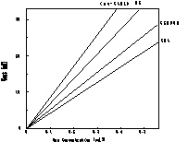 | 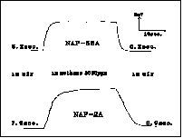
Gas sensitivity characteristics | Response characteristics

