Specifications
Input votage 8V to 28V, suggestat least 2S battery forUltra Long Range VTX
Extra features Smart audio 3000mw
power supply 5v camera @ under 500MA max.
output power 250/500/1000/2000/3000 MW
Antenna connector MMCX
Cable connector JST, 6PIN
Dimensions 36(W)x 36(D) mm, 30.5x 30.5 mm (hole)
Weight 23g (excluding adapter/ cable)
Kit contents 1xVTX, 1x cable

Channel
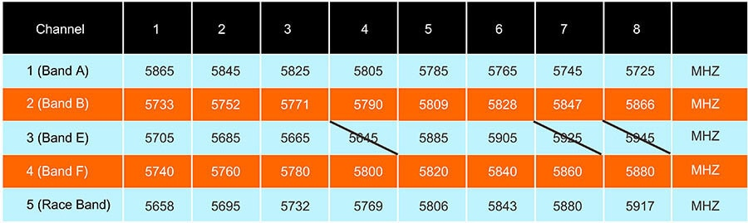

Notes:
Don't solder the cable to board directly if you see the sign"VDD" on the VTX board. you can refer to the product page wiring diagram or user manual.

PLUG THE ANTENNA BEFORE POWERING THE VTX
DO NOT REMOVE COOLING FAN
