KLS Electronics Co. Ltd.

Switch >> DIP Switch Series

KLS7-DP
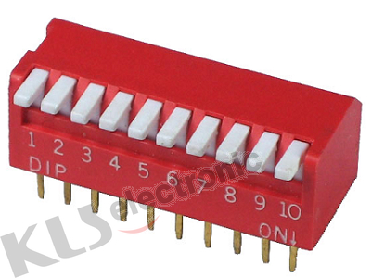

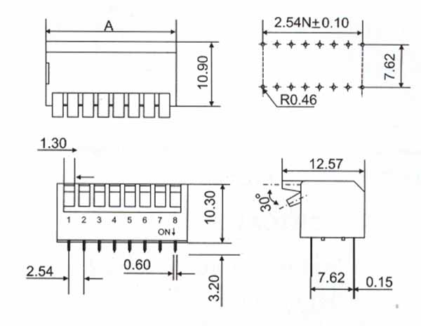

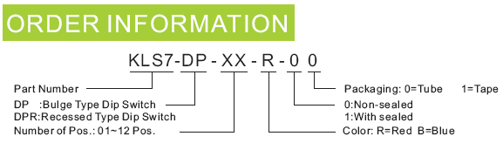

SPECIFICATIONS
Mechanical life | 2000 operations per switch
Operation Force | 1000gf max.
Stroke | 2.0mm
Operation Temp | -20/+70
Electrical life | 2000 operations per switch-24VDC,25mA
Contact Resistance | 50m max.at initial
Non-Switching Rating | 100mA, 50VDC
Switching Rating | 25mA,24VDC
Circuit | Single pole single throw

