KLS2-333K-3.50

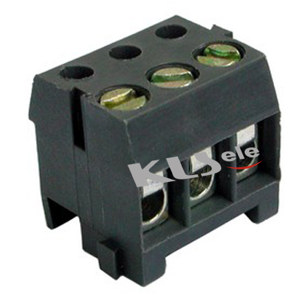

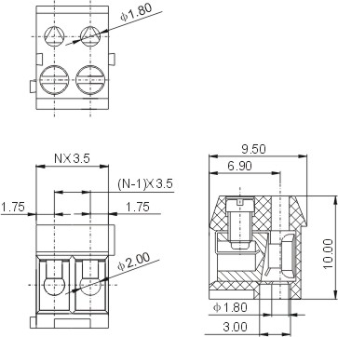

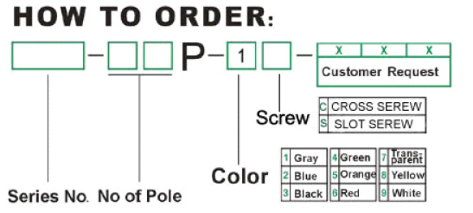

Pitch:3.5mm
Electrical
Rated Voltage/Rated Current | 300V/10A
Wire Range | 28-18 AWG, 1.0 mm2
Withstand Voltage | AC2000V/1Min
Insulation Resistance | 5000MΩ/DC1000V
Contact Resistance | 20 mΩ
Temp. Range | -30°C~+120°C
Torque | 0.2N.m (1.7Lb.in)
Length | 4.5-5 mm
Mechanical
Housing | PBT, UL94V-0
Screw | M2, Steel,Zinc-plated
Reed | Phosphor Bronze ,  Electroless nickel
Pin Header | Brass,Tin-plated

