KLS2-333J-3.50

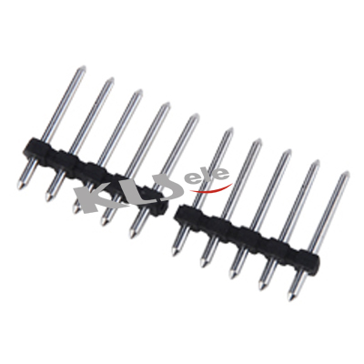

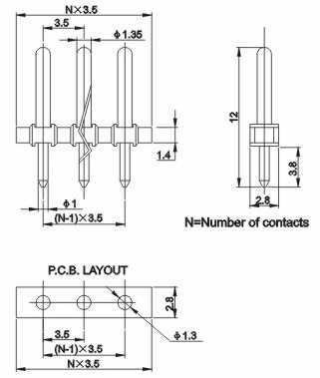

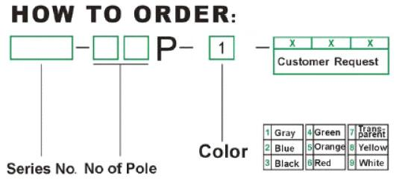

Pitch:3.5mm
Electrical
Rated Voltage/Rated Current | 300V/10A
Withstand Voltage | AC2000V/1Min
Insulation Resistance | 5000MΩ/DC1000V
Contact Resistance | 20 mΩ
Temp. Range | -40°C~+105°C
Mechanical
Housing | PA66, UL94V-0
Pin Header | Brass,Tin-plated

