Solar battery ESG-PWM2x10W

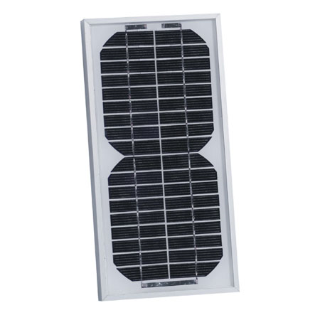

Power: 20W
Size: 285*280*18MM
Voltage: 12V

